Announcements

There will be a “Come and Go” baby shower for baby boy, Bryson here at the building on February 21st at 2:00 pm. Elisa is registered at Amazon. Precautions will be taken and safety is our focus, so please feel comfortable in joining us as we show our love and welcoming spirit to Bryson.

Ladies, mark your calendars for February 19-20 for Harding University’s Ladies Conference, Bloom. This years conference will be live-streamed here at the building beginning Friday the 19th at 5:15 pm. Please see the bulletin board in the foyer for more details.

Hillcrest Church of Christ in Neosho is hosting a ladies seminar March 12-13. The focus is “Shelter in a Time of Storm” featuring Donna Faughn. There is more information on the bulletin board.

We are getting ready to resume our Wednesday night Bible classes this month. We need your help. There is a form on our website that will help us plan for how many students we are likely to have, as well as a place to let us know if you would be willing to help in teaching.

Prayer List

Continue to remember the family of George Bowman in his passing.

Continue to remember Sean Turnage as he continues to recover from his recent surgery.

Continue to pray for those suffering with Covid: Monica Klingman’s mother, DeEtta, Chris Johnson’s mother, BettyWhittington’s daughter, Stephanie.

Prayer List (cont.)

Also, please continue to remember:
- Louise Perry
- Roger Montgomery
- Eitzen Family
- Whittington Family
- Dorothy Bagwell
- Loisell Tyler
- Bob Musson
- Tim and Susan Duffy
- Susan Duffy’s father

Bible Classes

Sunday morning Auditorium – “Your Kingdom Come” – A Study Through the Sermon on the Mount

Wednesday morning Ladies’ Bible Class, Love First
9:45 each Wednesday.

Wednesday evening Live-Stream – Making Our Calling and Election Sure
7:00 pm every Wednesday evening

Wednesday evening Ladies’ Bible Class, Faith Dare

Those Serving Next Week

Song Leader a.m. –
8:15 – Sammy McCain
10:30 – Mark Bagwell
Communion Lead –
8:15 – Dallas Dobbs
10:30 – Mitchell Whittington
Prayer and Scripture Reading –
8:15 – Randall Hunt
10:30 – Ray Reiss
Greeters –
8:15 – Gary McCool
Mike York
10:30 – Mike Lunsford
Chris Johnson
Video Operator – Matt Grisham
Worship Coordinator – Mark Tucker
Audio – Homer Makinson
Streaming – Abby Willis

Youth Notes

Please check out the Instragram and Youth Group Website, bellavistayouthgroup.com

Upcoming Events

SNH – January 31st

Other Notes
Church Family,
Thank you so much for your prayers, cards, and phone calls during my recent fall. It means so much to know others care.
In Christian Love,
Margaret Wicker

Dear Church Family,
Ron, James, and I feel so loved by your works of kindness! We are doing better! Pray we will be back soon. Cannot wait!!
Love you all,
The Beaty’s

Dear Friends,
Thank you for the memorial gift in Bill’s honor to Gospel Tracts. We enjoyed working in the ministry there when we were able. I appreciate your thoughtfulness and kindness extended to me and my family.
Love,
Mary Jane Hunter

Our Church Family,
Once again we have experienced your out pouring of love. The beautiful cards (with great words of support and encouragement), offers of help, and especially your prayers during my surgery and rehab are so deeply appreciated. Like so many we are truly blessed to be a part of the Lord’s Body at Bella Vista and are grateful for your thoughtfulness. We pray the Lord continue to show His strength and power and grow His church in the world, and that the work done at Bella Vista continue to be to his glory.
In Him,
Jerri Dobbs

Reaching Farther

Reach out to someone this week expressing thanks for what they have meant and continue to mean to you.

Moving Closer

Pay attention for opportunities for thankfulness, knowing that they may be found in unexpected places.

Growing Deeper

Start every day this week recalling all the blessings that God has given, and give him thanks for all.

Welcome Visitors
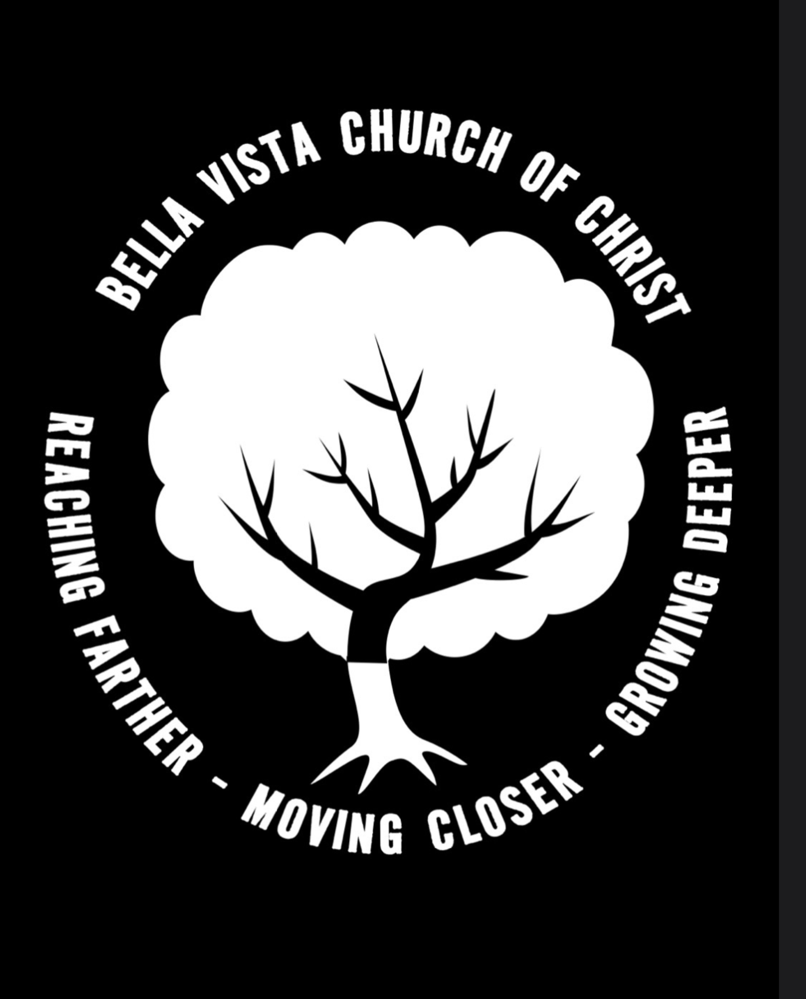
Thank you for being with us today. We hope the service today is meaningful and inspiring. We also pray that you will come back to be with us every opportunity you have.
Notes
Bella Vista Church of Christ
Sunday morning, February 7, 2021

Service Times
Sunday Morning Worship – 8:15 am
Sunday Morning Bible Class 9:30
Sunday Morning Worship – 10:30 am
Wednesday Night Bible Study Live-Streamed at 7:00 pm

Visit us online at: Bellavistachurchofchrist.com

Worship This Morning

8:15 a.m.
Song Service: Lee McCain
Prayer and Scripture Reading: Joe Hott
From a Place of Thankfulness – Jeff Grisham
Communion Lead: Chad Dobbs

10:30 a.m.
Song Service: Chris McSweeny
Prayer and Scripture Reading: Mike Spencer
From a Place of Thankfulness – Jeff Grisham
Communion Lead: Bob Spaw

Scripture reading this morning

I thank my God in all my remembrance of you, always in every prayer of mine for you all making my prayer with joy, because of your partnership in the gospel from the first day until now. And I am sure of this, that he who began a good work in you will bring it to completion at the day of Jesus Christ. It is right for me to feel this way about you all, because I hold you in my heart, for you are all partakers with me of grace, both in my imprisonment and in the defense and confirmation of the gospel. (Philippians 1:3-7 ESV)

